

**INDIAN INSTITUTE OF TECHNOLOGY,ROORKEE**

**PROJECT**

**FOCUS WEB**

**GROUP 9**

**Submitted by**

Nimmala Sai Bhargav (21114067)

Nenavath Suresh Kumar (21114066)

Taddi Satya Shyam Sundar (21114102)

Sapavath Yashwanth Krishna (21114093)

Aditya Singh (21114006)

Sani Shashi praneeth (21114089)

Guided by

**Prof.Sandeep Kumar**

Submitted to

**Indian Institute of Technology ,Roorkee**

**Contribution of each member**

* Shyam Sundar: (Mob No: 8125817460)

Bored Page, Front end Design

* Shashi Praneeth: (Mob No: 8309969012)

Tasks Page, Integration

* Suresh: (Mob No: 9110743872)

Search Page,Front end Design

* Yashwanth: (Mob No: 9346247892)

Pomodoro Clock,Front end Design

* Sai Bhargav: (Mob No: 8688209485)

Notes, Pomodoro(storage)

* Adithya: (Mob No: 8738900736)

Debugging,Dark Mode

Frontend-Yashwanth, Suresh , Shyam Sundar,Adithya

Backend-Shashi, Sai Bhargav

**INTRODUCTION:**

We often try to achieve more in less time. We used to think, the more I work, the more productive webecome. But we were wrong. There is a big difference between being busy and being productive.We were always looking for ways to be more productive. I read multiple books, used different tools and techniques. But deep down I felt I need a simple, minimal productivity tool then the idea of this app was born.

The idea was quite simple. All we wanted was a bunch of productivity tools like a Pomodoro clock, a to-do list, sticky notes altogether. Nothing fancy and complicated.We wanted to have all these tools somewhere we can see all day. And we thought what's better than a browser's new tab.

**DEVELOPMENT TOOLS :**

The development tools that were used while implementing the project idea into a web are listed below :

* We used Atom and VS Code as an IDE
* For designing the User-Interface : wire frames
* Frontend Development tools:

1. HTML
2. CSS
3. JAVA SCRIPT
4. REACT (learned but not successfully implemented)

* Backend Development tools :

1. Node JS

Data base : Non SQL( MongoDb ) ,We used mongos .

* SYSTEM REQUIREMENTS :

**On Client Side :**

* Internet

**On server side :**

* Online database of MongoDb (cluster atlas)

User Flow Diagram:

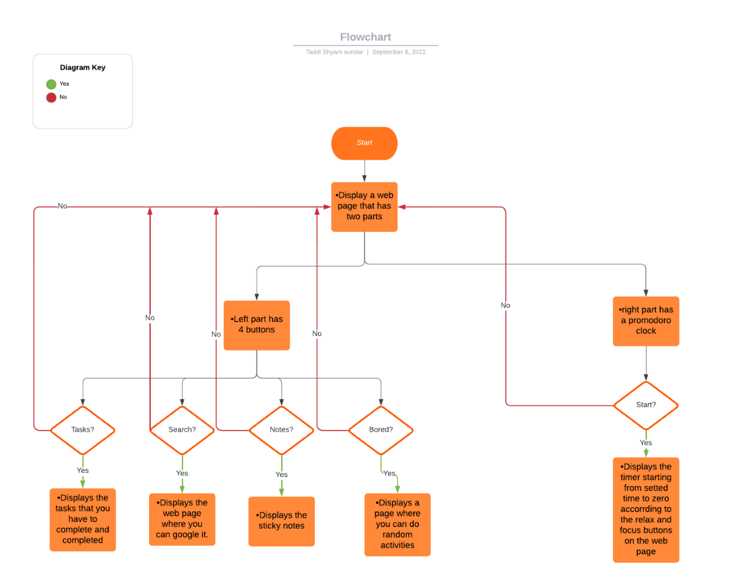

**Features:**

* Simple and user friendly user interface.
* User can maintain Sticky Notes (important notes).
* User can add tasks to To do list.
* Search engine
* In the search mode we implemented blocked websites.
* User can keep track of time with Pomodoro Clock.
* Random Activity is used when the user gets bored.
* Dark mode.

**Wire frames:**

**Tasks:** 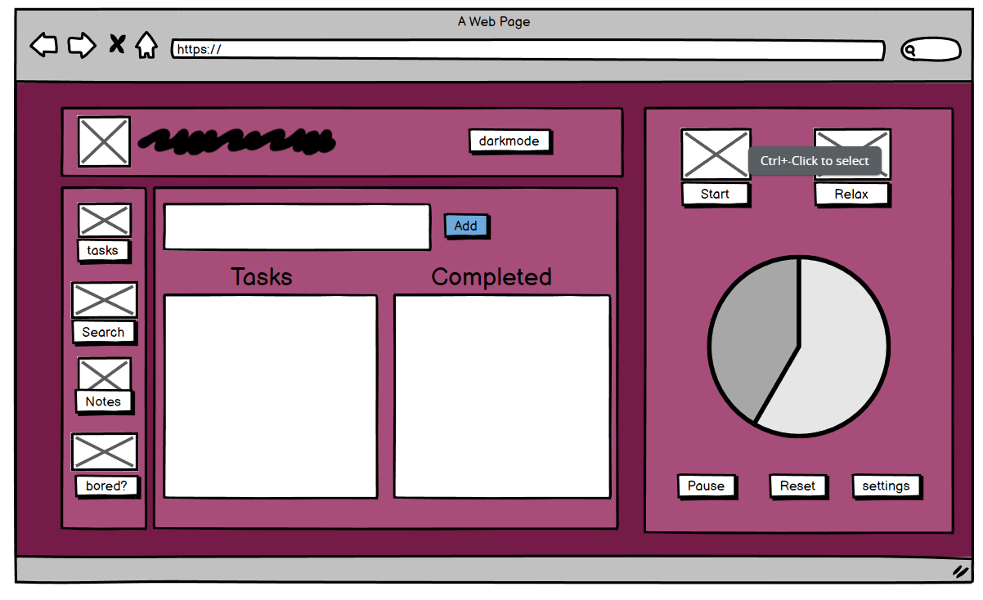

**Search:** 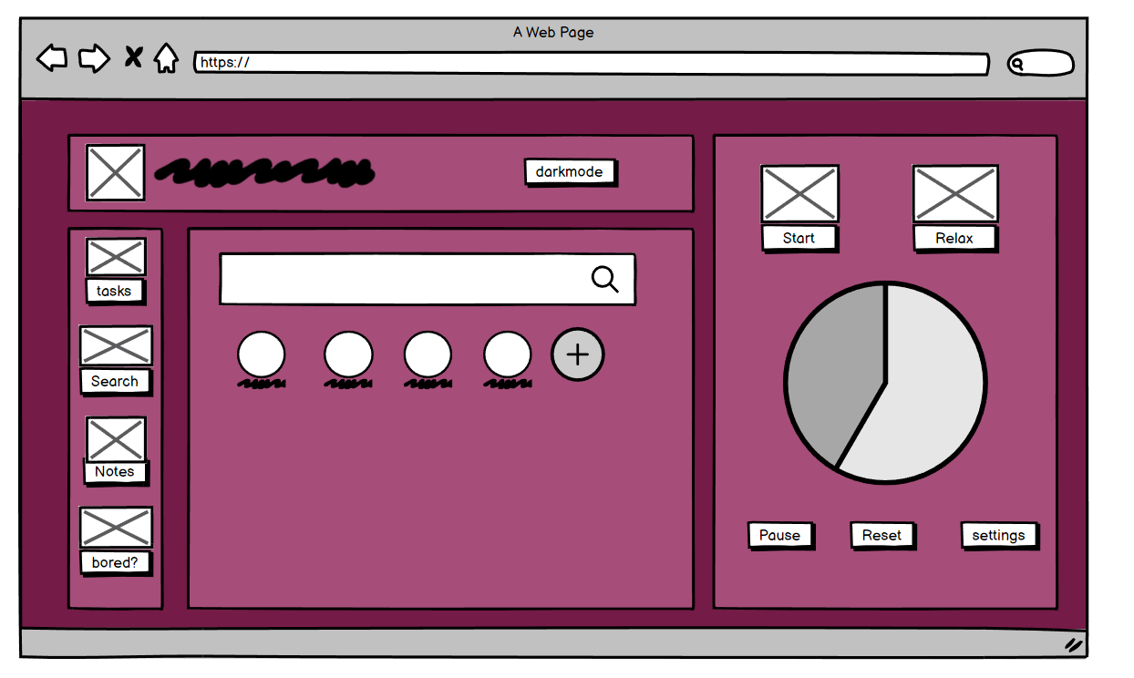

**Notes: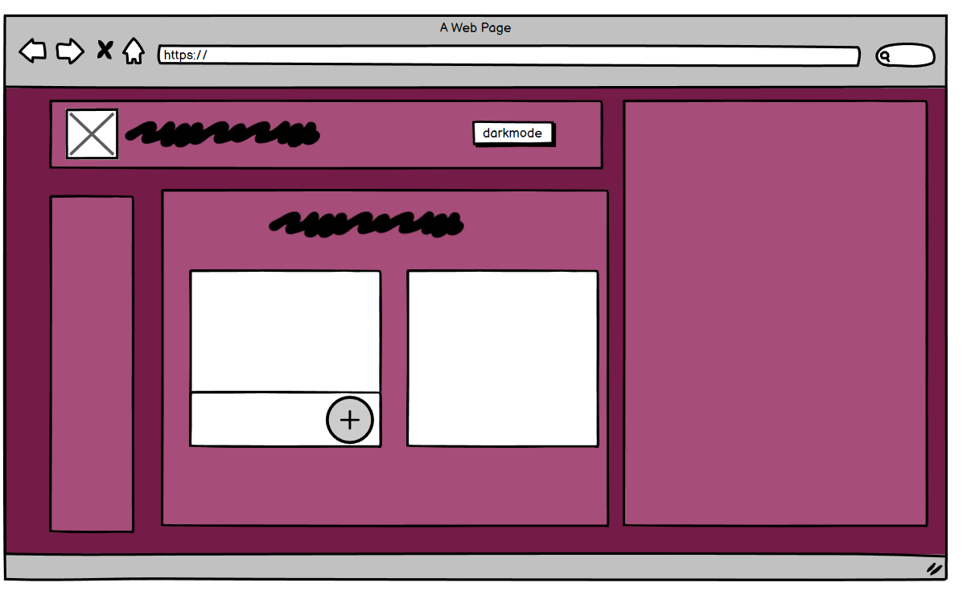**Bored: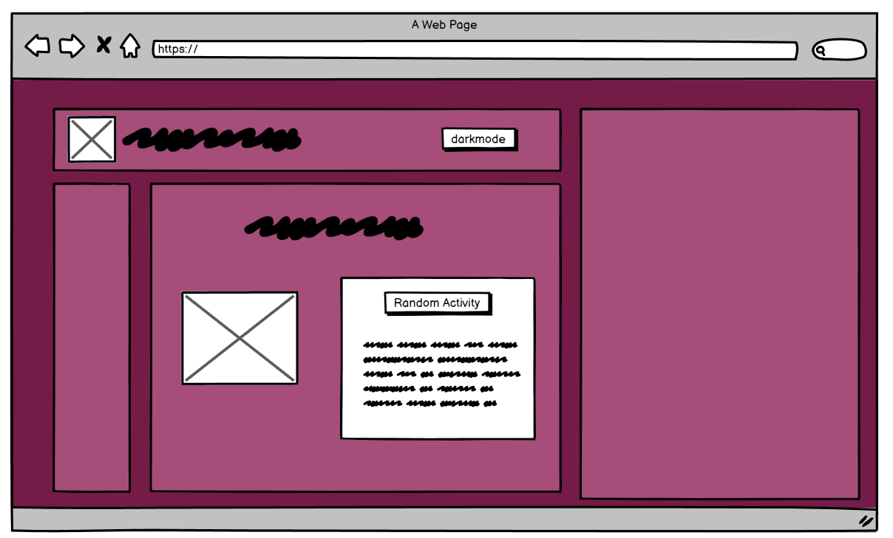

Snapshots and Applications :

**TO DO LIST page**:

Here user can add their to-do list.

**Light-mode:**

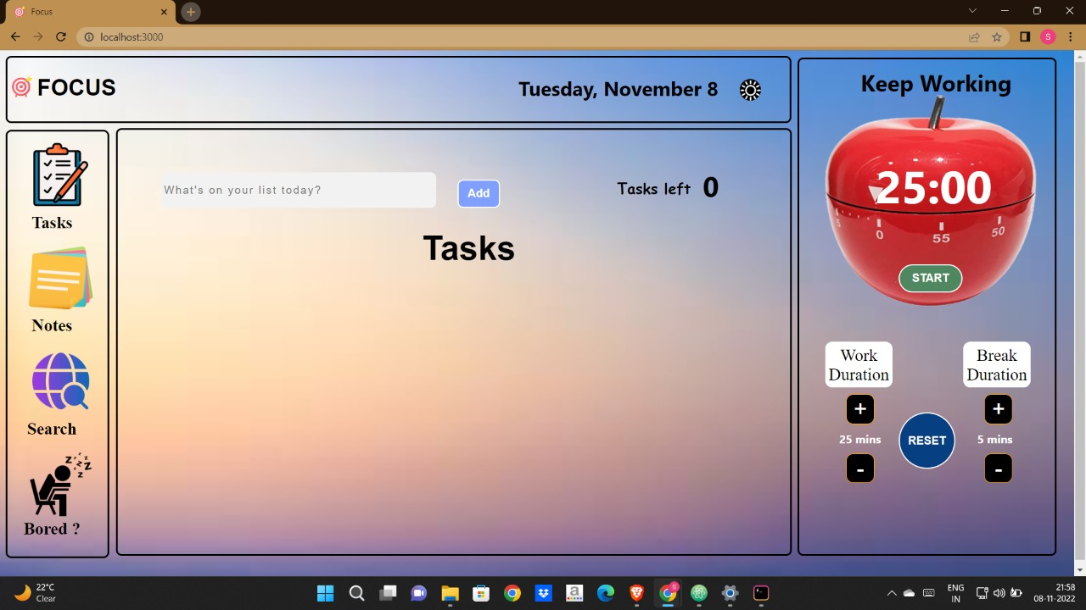

**Dark-mode:** 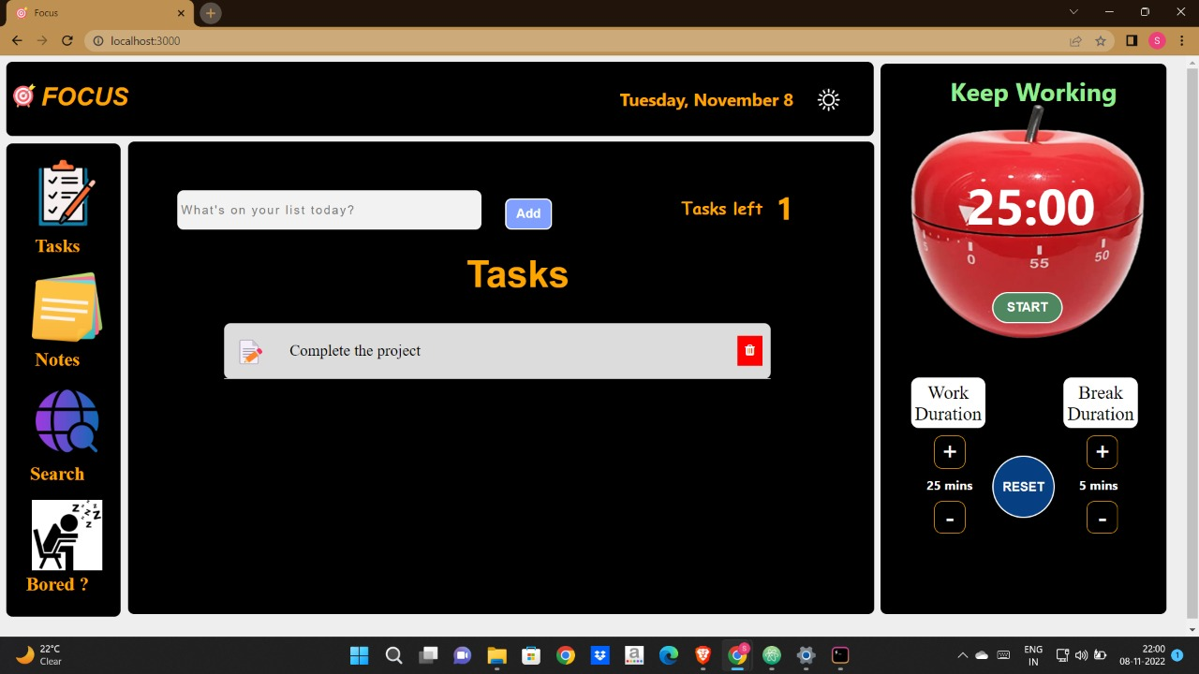

NOTES page :Here user can important Sticky Notes.

Light-mode:

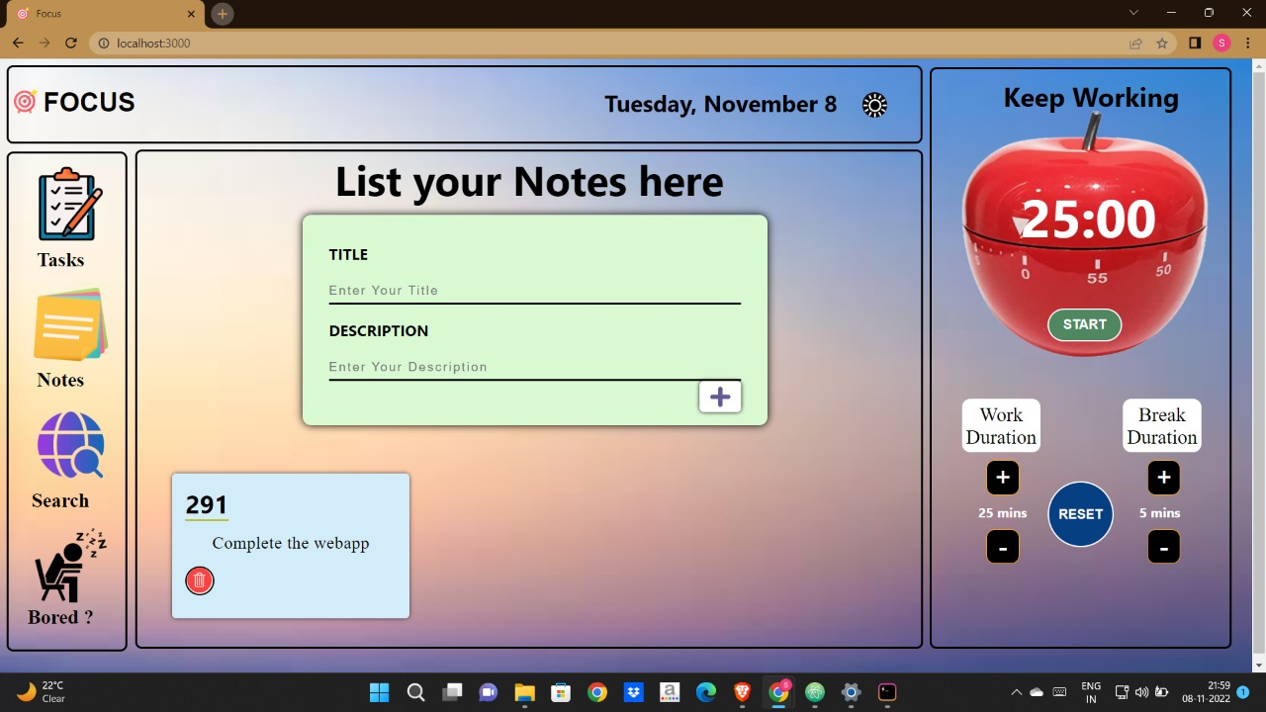

Dark-mode :

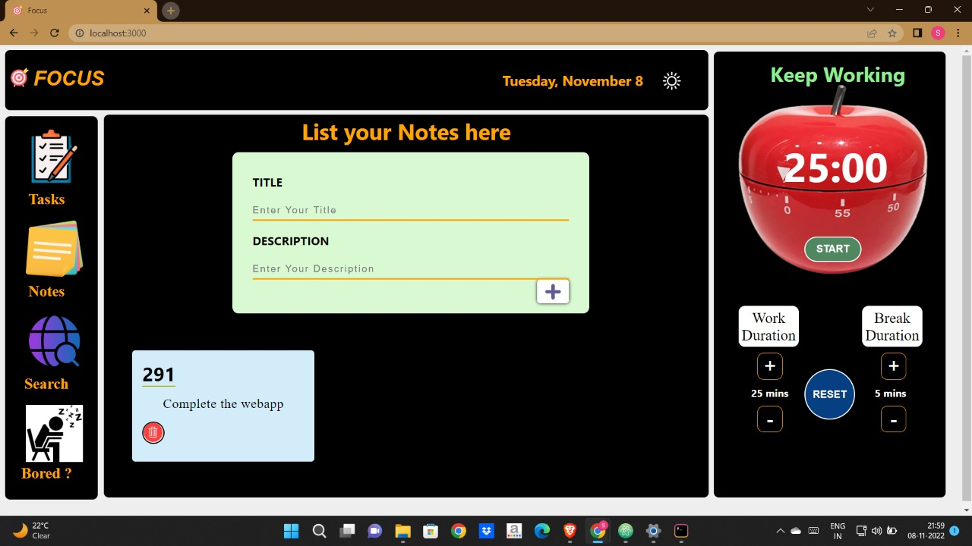

SEARCH page:Here user browse in internet.

Light-mode

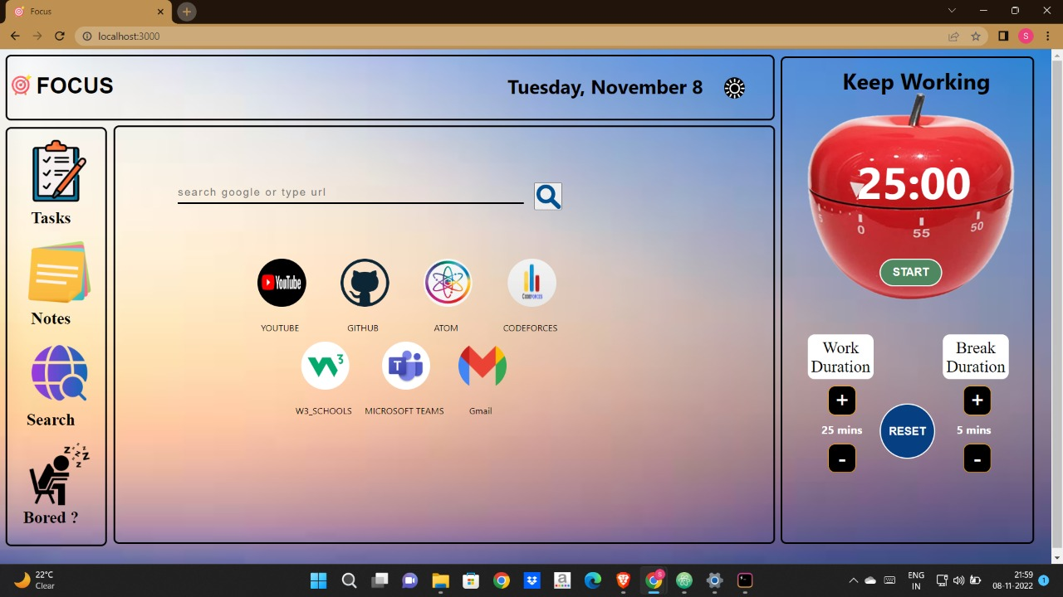Dark-mode: 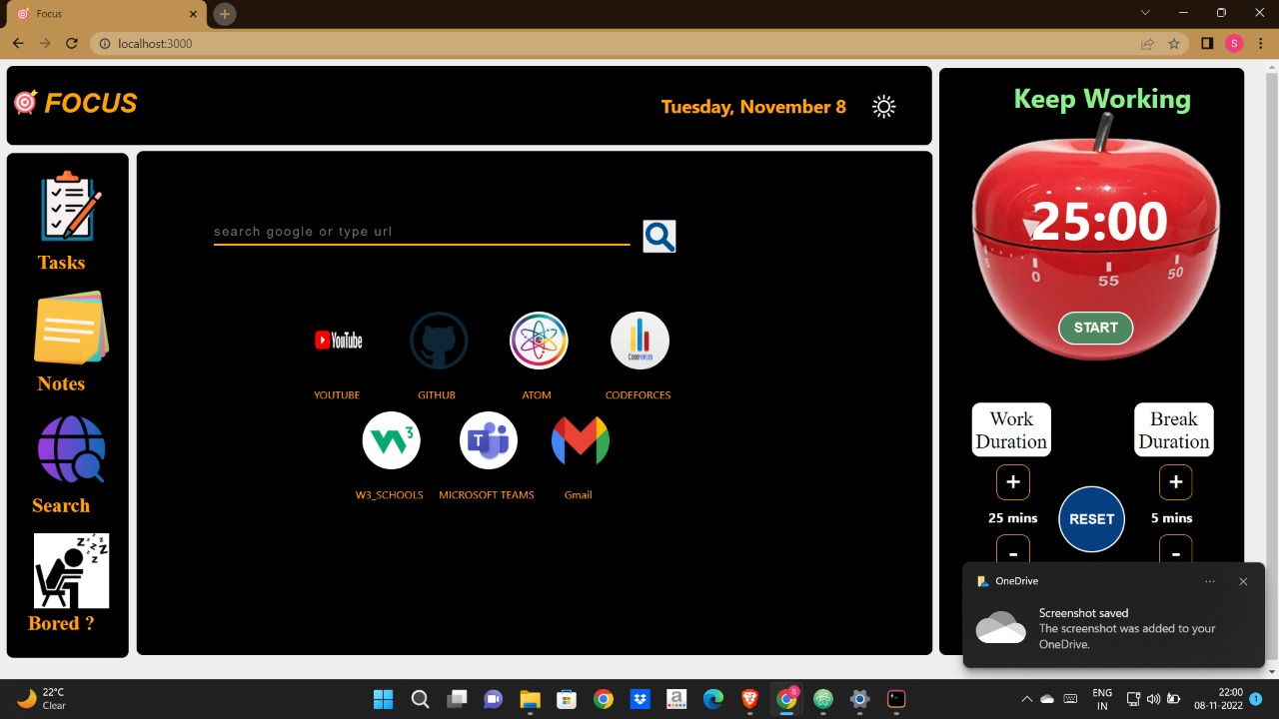

RANDOM-ACTIVITY :

Here user will get a random activity to do when they get bored.

Light-mode :

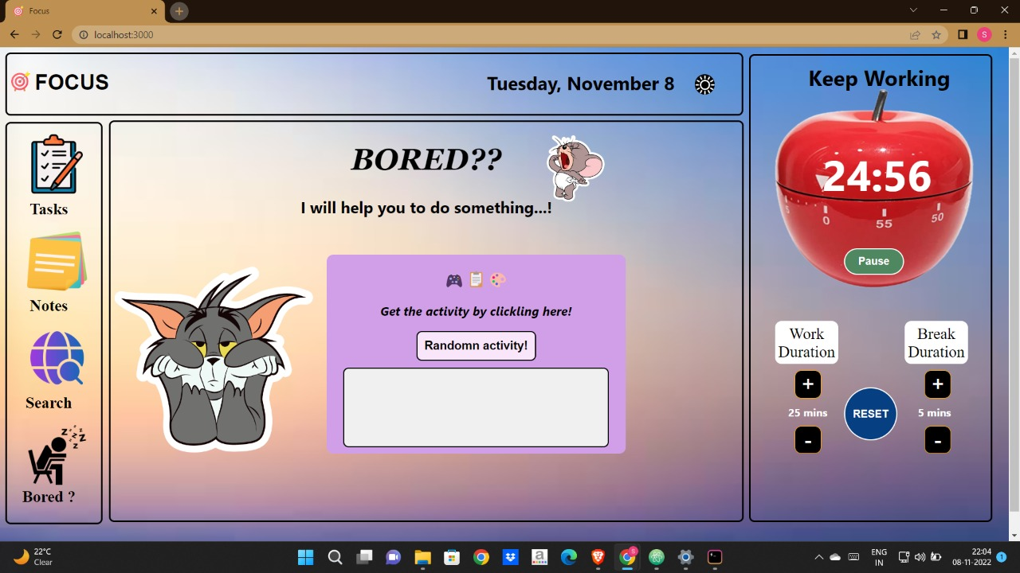

Dark-mode:

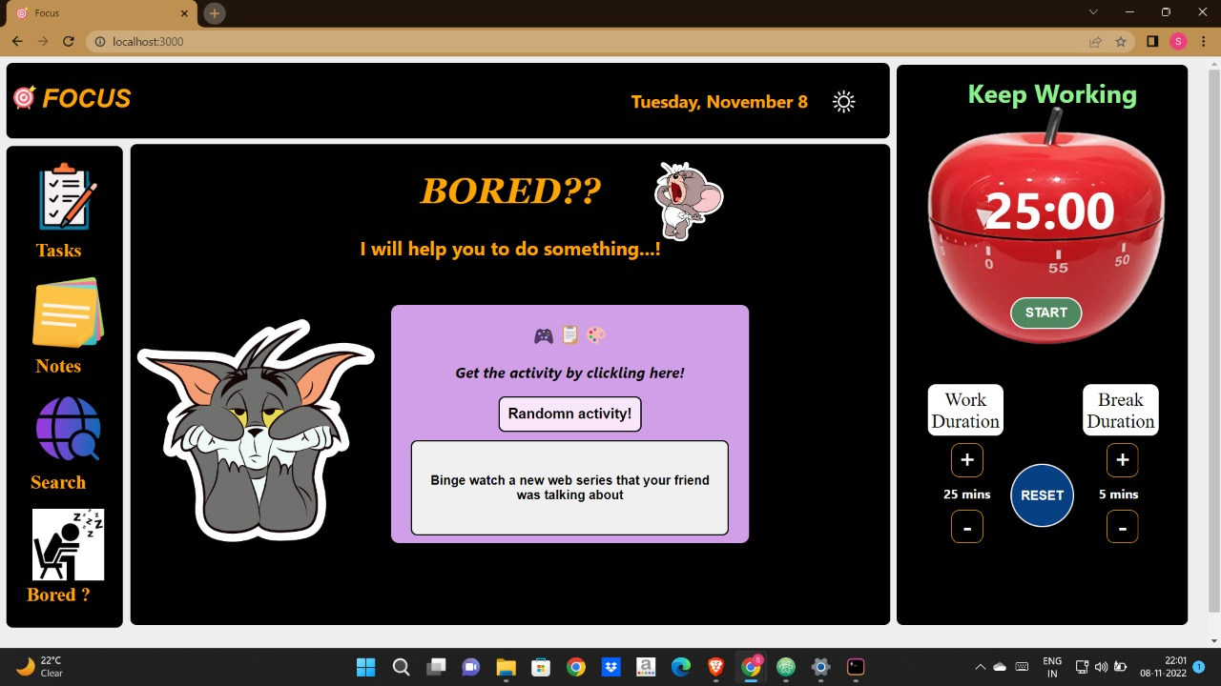

**FUTURE SCOPE :**

* We can add chrome extension .
* Shortcut button can be add the shortcuts of required websites.
* Login page to maintain the record of a user.